Curriculum Vitae
personal Information
Name | Samar Mahmoud Mohammed El-Gammal | 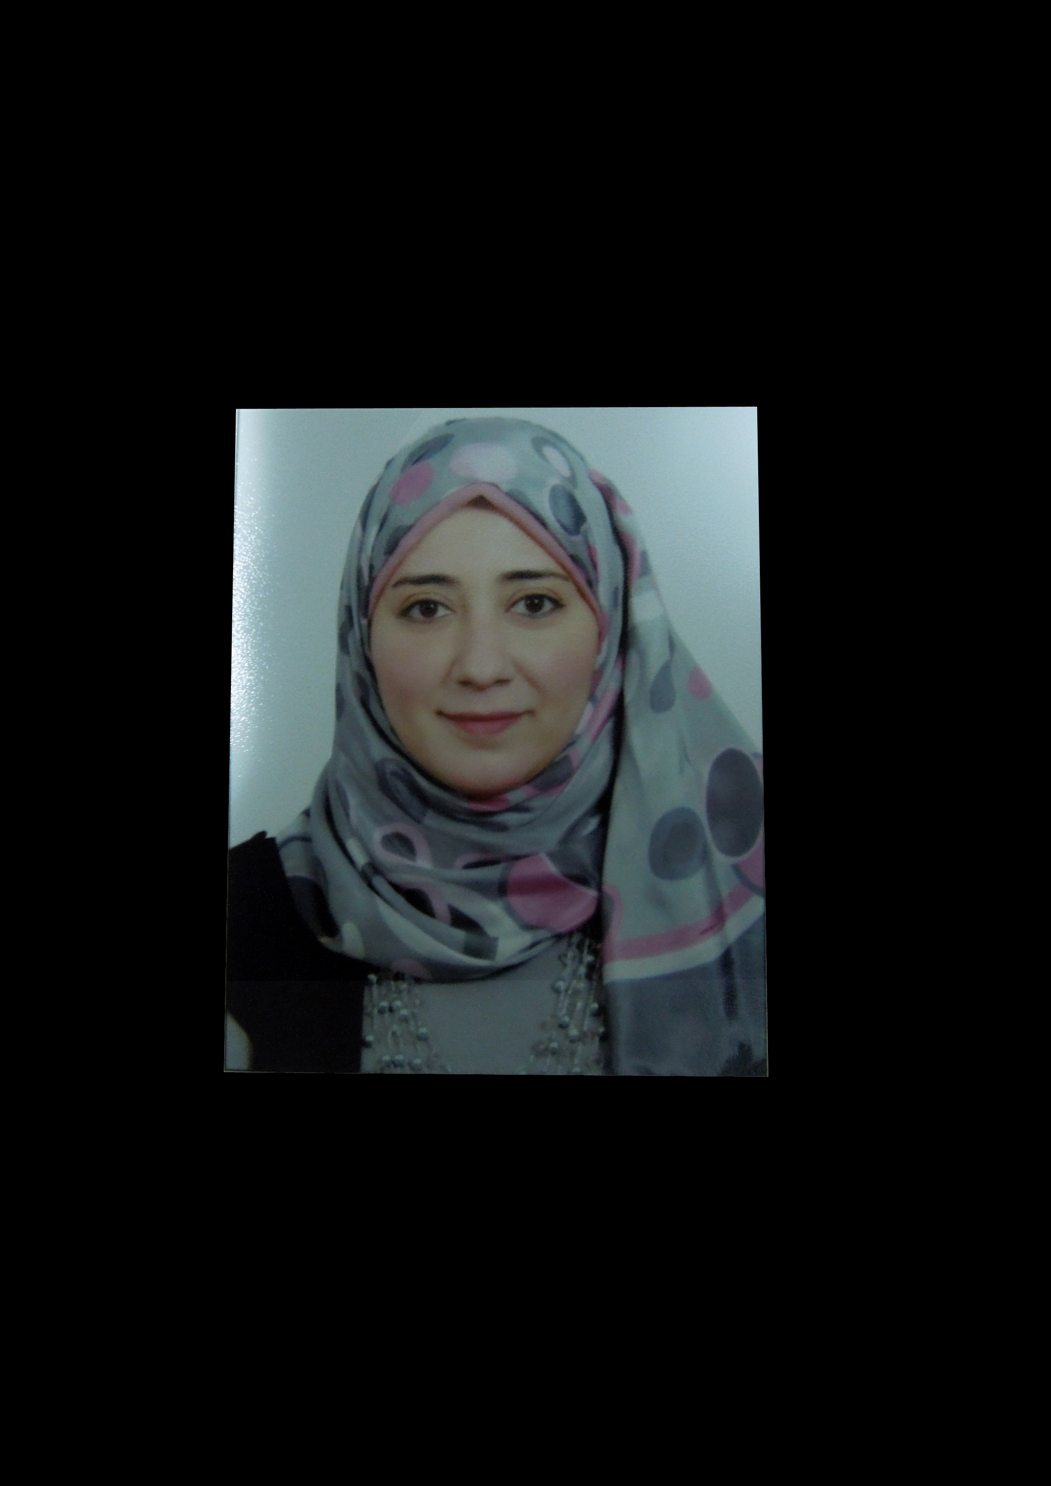
Title | Lecturer of Anatomy and Embryology
Date of birth | 13-3-1986
Place of birth | Giza
Citizenship | Egyptian
Contact Information
Home phone | 33918381
Work phone | 01004405897
Mobile phone | 01004405897
E-mail (s) | samar_elgammal@cu.edu.eg  samarelgammal13@yahoo.com  dr.samarelgammal13@gmail.com
Web site (s)
Current Address | Al Haram, pyramids gardens, khofou gate, 452 z, giza
Educational Qualifications
Ph.D. Faculty of Veterinary Medicine, Cairo University, 2016
M. Sc., Faculty of Veterinary Medicine, Cairo University, 2012
B. Sc., Faculty of Veterinary Medicine, Cairo University, 2008
Academic Positions
Lecturer, Anatomy and Embryology Department, Faculty of Veterinary Medicine, Cairo University, 2016
Assistant Lecturer, Anatomy and Embryology Department, Faculty of Veterinary Medicine,
Cairo University, 2012
Demonstrator, Anatomy and Embryology Department, Faculty of Veterinary Medicine,
Cairo University, 2009.

Thesis Title
Ph.D.: Anatomical Studies on the Blood Vessels of the Gastrointestinal Tract of the Turkey, With Special Reference to the Hepatic Portal System and Biliary Elimination of some Drugs.
M. Sc.: Anatomical Studies on the Blood Supply of the Pelvic Limb of the Chicken; With Special Reference to the Renal Portal System and Renal Elimination of some Drugs.
Areas of experience
-Teaching the anatomy of equine.
-Teaching the anatomy of the domestic fowl and domestic turkey.
-Teaching the hepatic and renal portal systems in domestic fowl and domestic turkey.
Projects
Awards
Professional Qualifications
Conferences

Training courses

Computer Skills
-Office(word, PowerPoint)
- Internet

Language Skills
Mother language: Arabic
Other language: English
Professional Memberships
Other activities
List of publications
Abo-EL-Sooud, K., G. A. Swielim, E. F. Khalifa, and S. M. EL-Gammal,
"Effect of different sites of intramuscular injection on elimination, bioavailability and tissue residues profile of gentamicin in broiler chickens", Insight Poultry Research, vol. 1, issue 1, pp. 1-7, 2012.

Swielim, G. A., Khalifa, E. F., and EL-Gammal, S. M.
"Anatomical studies on the venous drainage of the pelvic limb of the chicken", Kafrelsheikh Vet. Med. J. Vol. 10 No. 1, pp. 277-315, 2012.

Swielim, G. A., Khalifa, E. F., and EL-Gammal, S. M.
"Anatomical studies on the arterial blood supply of the pelvic limb of chicken", SCVMJ, XVII (2), 2012.

K. Abo-EL-Sooud; G.A. Swielim; Y.R. Wally and Samar M. EL-Gammal
"Comparative biliary and serum kinetics of doxycycline after oral and intramuscular routes with special reference to its unique entero-hepatic circulation in turkeys", Wulfenia Journal, 2016.

Nora, A. shaker and Samar M. EL Gammal
"Comparative Anatomical Studies on the Fetal Remnants in Donkey (Asinus Equus) And Camel (Camelus Dromedarius)", IOSR-JAVS, 2018, 11(5):12-21.

Meray Nabil Ramsis, Samar M. EL-Gammal, Khaled Abo-EL-Sooud, Gamal A. Swielim
"Anatomical Studies on the Arterial Blood Supply of the Pelvic Limb of Geese", Adv. Anim. Vet. Sci. 9(4): 604-614
Http://dx.doi.org/10.17582/journal.aavs/2021/9.4.604.614.

Publications statistic
Journal’s Publication |  | Conference’s Publication |  | Authors |  |  | Total
Local | International | Local | International | Single | Shared |  | Total
 |  |  |  |  | Internal | External | Total

